# Brainstorm&Idea Prioritization Template

Date: 16 July 2025

Team ID: LTVIP2025TMID46030

Project Name: HEMATOVISION – ADVANCED BLOOD CELL CLASSIFICATION USING TRANSFER LEARNING

Maximum Marks: 4 Marks

Step-1: Team Gathering, Collaboration and Select the Problem Statement

Team Assembly  
Members discussed and agreed upon key roles including:  
- Data Science Lead  
- Model Developer  
- Research Analyst  
- Tester and Validator  
  
Problem Statement Chosen:  
Improve the accuracy and speed in classifying blood cells using transfer learning models, while addressing challenges like:  
- Real-time processing  
- Class imbalance  
- Visual similarity among cell types

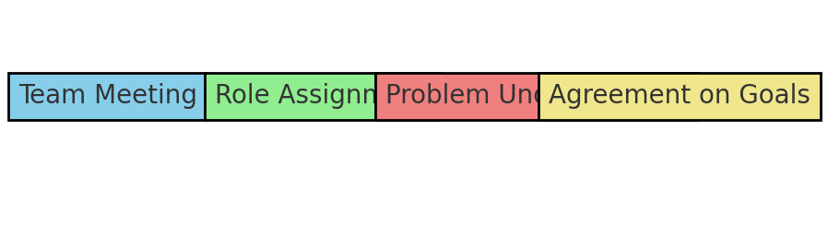

## Step-2: Brainstorm, Idea Listing and Grouping

|  |  |
| --- | --- |
| Raw Ideas | Grouped Under |
| Use MobileNet for lightweight model | Transfer Learning Techniques |
| Augment dataset for rare cell types | Data Preparation&Preprocessing |
| Apply real-time detection using OpenCV | Deployment Strategies |
| Cross-validation for better generalization | Model Evaluation Techniques |
| Compare VGG16, ResNet50, EfficientNet | Model Architecture Selection |
| Monitor training with TensorBoard | Training&Monitoring Tools |

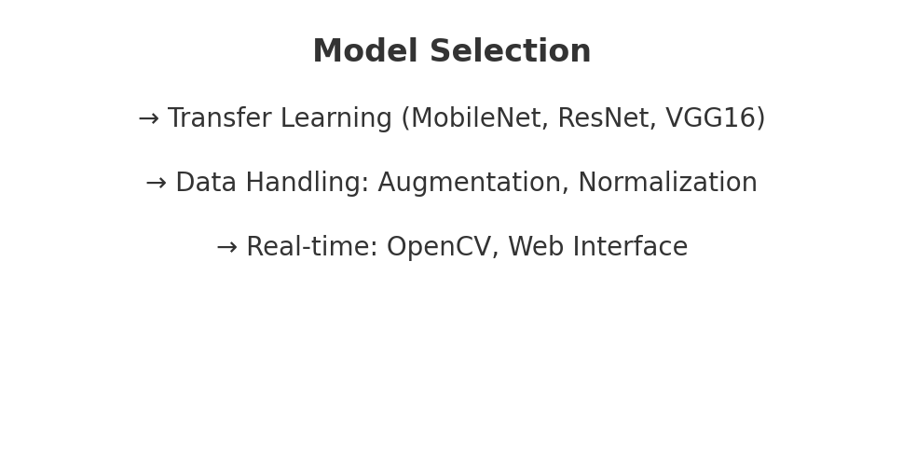

## Step-3: Idea Prioritization

|  |  |  |  |
| --- | --- | --- | --- |
| Idea | Feasibility | Impact | Priority |
| Use MobileNet model | High | High | High |
| Augment data using rotation, flip | High | Medium | Medium |
| Deploy on real-time system using OpenCV | Medium | High | High |
| Compare performance with other architectures | Medium | Medium | Medium |
| Apply class weight to handle imbalance | High | High | High |
| Integrate TensorBoard monitoring | High | Medium | Medium |

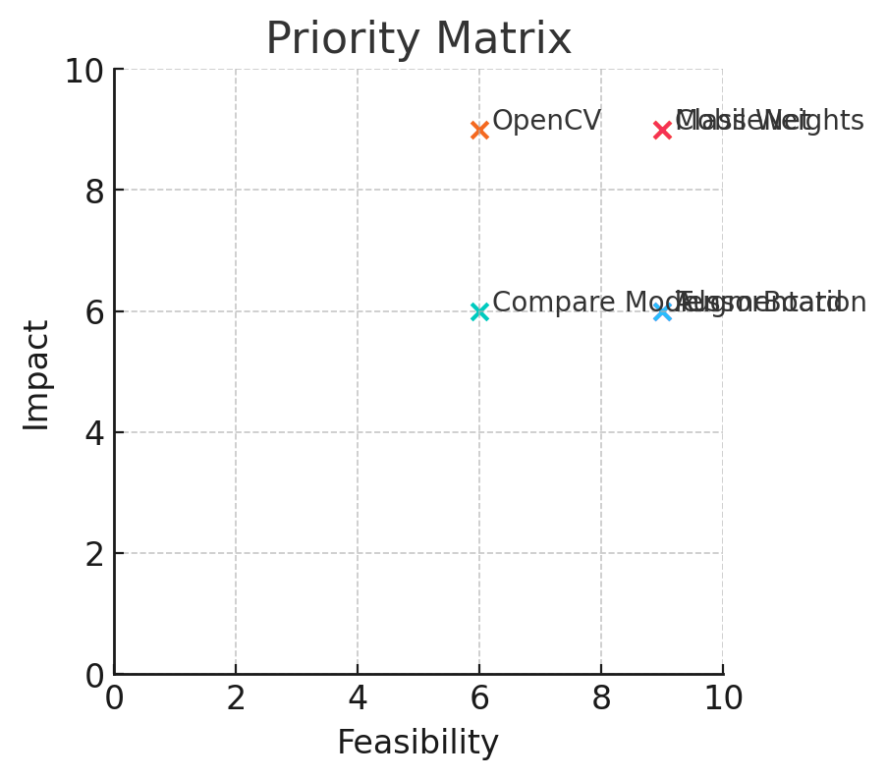

## Final Chosen Direction

Architecture: MobileNet with transfer learning  
Dataset Strategy: Data augmentation + class weights  
Implementation: Real-time detection using OpenCV  
Evaluation: Accuracy, Recall, and Confusion Matrix